**Homework #1**

**Problem 1**

**Script**

clear all

clc

close all

format compact

% Use 1/2 inch increments for calculating the deflections

x = 0:0.5:360;

% Calculate the defelction

for i=1:length(x)

y(i)=(800*x(i)^3 - 13.68*10^6*x(i) - 2.5*x(i)^4 +2.5*(x(i)-120)^4*(x(i)>=120) +600*(x(i)-240)^3*(x(i)>=240))/(3.190*10^9);

end

[max_y, max_x]=max(abs(y));

% Plot

hold on

plot(x,y,'Linewidth',2 );

plot(x(max_x),y(max_x),'o','MarkerSize',8,'MarkerEdgeColor','k','MarkerFaceColor','r')

text(x(max_x)*1.05,y(max_x)*1.05, ['(',num2str(x(max_x)),',',num2str(y(max_x)),')'])

xlabel('inch', 'FontSize', 18);

ylabel('defelction', 'FontSize', 18);

hold off

**Graph**

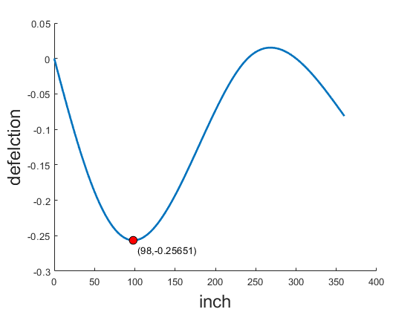

**Problem 2**

**Script**

clear all

close all

clc

format compact

% 1.Enter data from file Points.txt to Matlab workspace

MyFile = fopen ('Points.txt','rt');

A=textscan(MyFile,'%f %f','HeaderLines',1);

A=cell2mat(A);

fclose(MyFile);

x=A(:,1);

y=A(:,2);

% 2.Draw the polygon;

figure;

hold on

plot([x;x] ,[y;y],'Color','r','Linewidth',2,'DisplayName','Polygon')

% 3.Calculate the area of the polygon, print the answer to the Command Window;

area = area_of_the_polygon(x,y);

fprintf('the area of the polygon %g\n',area);

% 4.Calculate the coordinates of the centroid of the polygon,print the answer to the Command Window

[coordinates_x,coordinates_y] = coordinates_of_the_centroid(x,y,area);

fprintf('the coordinates of the centroid of the polygon (%g,%g)\n',coordinates_x,coordinates_y);

% 2.Draw the coordinates;

plot(coordinates_x ,coordinates_y ,'o','MarkerSize',8,'MarkerEdgeColor','k','MarkerFaceColor','g','DisplayName','Center')

plot(x ,y ,'o','MarkerSize',8,'MarkerEdgeColor','k','MarkerFaceColor','r','DisplayName','Point')

legend ('Fontsize',12,'FontWeight','bold')

hold off

function area = area_of_the_polygon(x,y)

n=length(x);

area = 0;

for i = 1:n-1

area = area + 1/2 *(x(i) * y(i+1)-x(i+1) * y(i));

end

end

function [coordinates_x,coordinates_y] = coordinates_of_the_centroid(x,y,area)

n=length(x);

coordinates_x = 0;

coordinates_y = 0;

for i = 1:n-1

coordinates_x = coordinates_x +(x(i)+x(i+1) )* (x(i) * y(i+1)-x(i+1) * y(i))/6/area;

coordinates_y = coordinates_y + (y(i)+y(i+1))* (x(i) * y(i+1)-x(i+1) * y(i))/6/area;

end

end

**Result**

the area of the polygon 29.575

the coordinates of the centroid of the polygon (1.15054,3.07711)

**Graph**

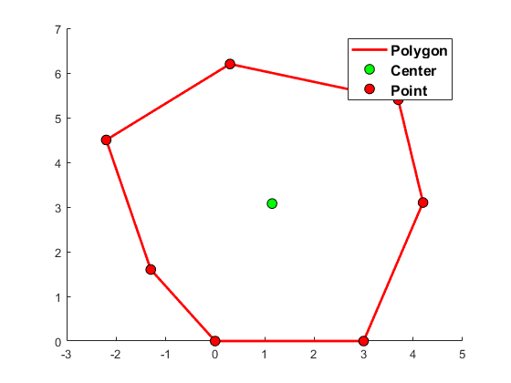

**Problem 3**

**Script**

clear all

close all

clc

% Create File

fid = fopen('Problem3_Result.txt', 'wt');

payment=1199.11;

% Calculate Balance

Balance_End =repmat(200000,1, 360);

Balance_Begin=repmat(0, 1, 360);

Balance_Begin(1)=Balance_End(1)*1.005;

Balance_End(1)= Balance_Begin(1)-payment;

for month = 2:360

Balance_Begin(month)=Balance_End(month-1)*1.005;

Balance_End(month)=Balance_Begin(month)-payment;

end

% Write File

fprintf (fid,' Beginning Ending \n');

fprintf (fid,'Month Balence Payment Balance \n');

fprintf (fid,'===== ========= ======= ======= \n');

for month = 1:360

if month<=12

fprintf (fid,'%5i %-9.2f%8.2f%10.2f\n',month,Balance_Begin(month),payment,Balance_End(month));

end

if month==359

fprintf (fid,'\n\n\n');

end

if month>=359

fprintf (fid,'%5i %-9.2f%8.2f%10.2f\n',month,Balance_Begin(month),payment,Balance_End(month));

end

end

fprintf(fid,'\nFinal balance to be refunded = %.2f\n',Balance_End(month));

fclose(fid);

**Result**

Beginning Ending

Month Balence Payment Balance

===== ========= ======= =======

1 201000.00 1199.11 199800.89

2 200799.89 1199.11 199600.78

3 200598.79 1199.11 199399.68

4 200396.68 1199.11 199197.57

5 200193.55 1199.11 198994.44

6 199989.42 1199.11 198790.31

7 199784.26 1199.11 198585.15

8 199578.07 1199.11 198378.96

9 199370.86 1199.11 198171.75

10 199162.61 1199.11 197963.50

11 198953.32 1199.11 197754.21

12 198742.98 1199.11 197543.87

359 2383.31 1199.11 1184.20

360 1190.12 1199.11 -8.99

Final balance to be refunded = -8.99